First confirmed reproduction of the translocated lynx in the Slovenian Alps - lynx Aida has three kittens
25. 8. 2021
In the middle of August, two hikers from Gorenjska, Slovenia, saw three lynx kittens and lynx Aida by the forest road on Jelovica plateau. LIFE Lynx project team confirmed that Aida, which was translocated from Romania, was present in the area at the time. According to the movement data from her collar, the kittens are about a month old.

Photos and data from lynx Aida’s collar affirm that this is the first confirmed reproduction of the translocated lynx in the Slovenian Alps. Two hikers that saw the lynx kittens described the event: “At first we thought that they were young foxes, but soon we discovered that they were lynx kittens. The surprise was even greater when we saw their mother take the kittens from the road to safety. We stayed in our car, so we wouldn’t disturb them too much”, said Mateja and Petra, the lucky hikers.
Lynx encounters in the wild are very rare, especially seeing lynx with kittens. It is important not to disturb the animals, since these first months are crucial for lynx survival. During the denning period, females move their kittens quite often to reduce the smell, which protects them from potential predators. However, in nature, not all kittens make it to adulthood; usually, the mortality in the first year is around 50%.
How many of the kittens will survive will be monitored also by camera-trapping monitoring, coordinated by Rok Černe from Slovenia Forest Service: “We just started lynx-monitoring season 2021/2022 and the LIFE Lynx project team plans to set some camera-traps also in Gorenjska region, so we can monitor if also Julija and Lenka, which were released this spring, were involved into reproduction.”

Video of the lynx kittens.
More information about the project https://www.lifelynx.eu/ and life.lynx.eu@gmail.com.
Follow us on Facebook: https://www.facebook.com/LIFELynx.eu/
and https://www.facebook.com/lifelynx.hr/

Contact for the media: Vesna Oražem, Zavod za gozdove Slovenije vesna.orazem@zgs.si, phone: 051/653-807.
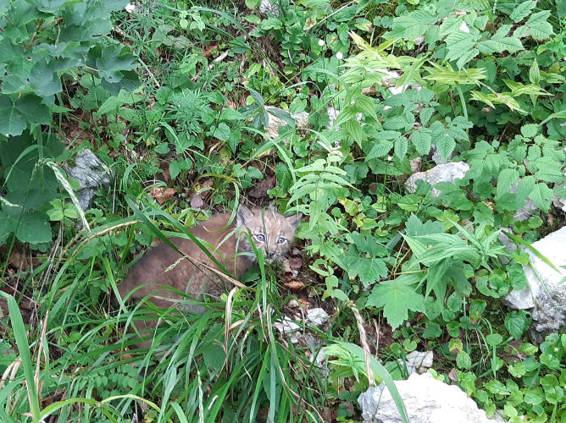
PHOTO 1: Lynx kitten in the high grass beside the forest road. Photo: Mateja Mohorič
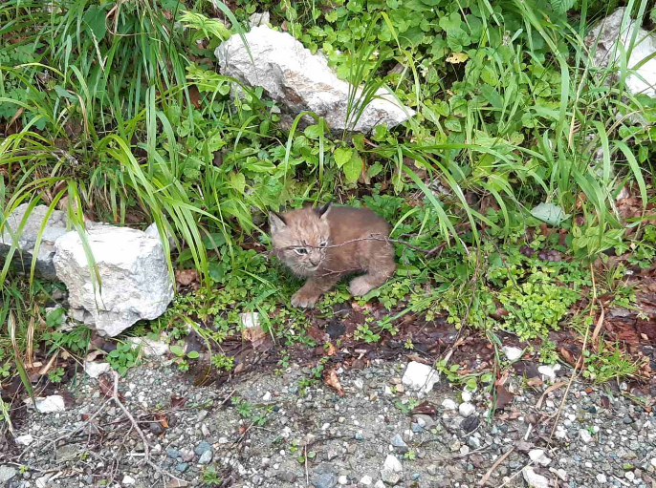
PHOTO 2: Lynx kitten beside the forest road. Photo: Mateja Mohorič
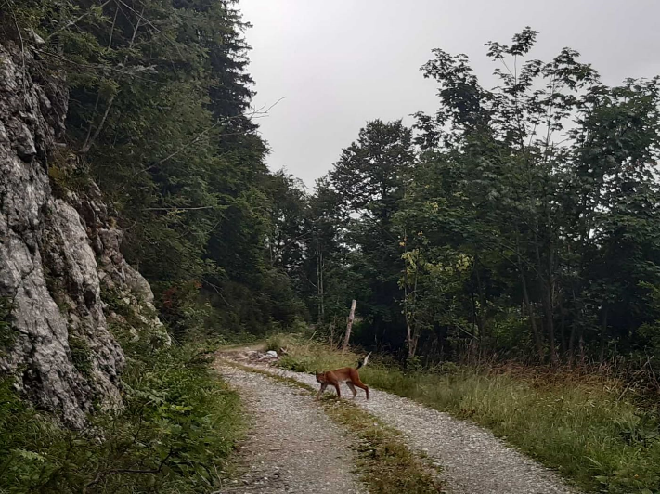
PHOTO 3: Female lynx Aida transferred the kittens to another location. Photo: Mateja Mohorič

