First two lynxes released into nature in Slovenian Alps, three more to go

Press release

26. 4. 2021

First two lynxes, named Zois and Aida were released from the quarantine enclosure in Gorenjska region (North-West region of Slovenia) on Monday, April 26, 2021. Together, nine lynxes were already released in the scope of the LIFE Lynx project in the Dinaric-SE Alpine lynx population. On Wednesday, three more will be released in Triglav National Park.
Long-time survival of the species in Dinaric Mountains and the Alps depends on this stepping-stone population, which will enable a durable connection between both areas. Creating smaller population stepping stones is accepted as the best practice of conserving lynx populations in human-dominated landscapes of Europe. The LIFE Lynx project continues the efforts of lynx reinforcement in the South-Eastern Alps in 2014, when two lynxes were translocated from the Swiss Jura Mountains and released in the Tarvisiano region in Italy.
Translocation of lynxes to Gorenjska region was an enormous challenge for the LIFE Lynx project since there were no confirmed lynx reproductions recorded in this area from the end of the 19th century. In March, the first lynx Tris (named after the highest mountain in Slovenia, Triglav, combined with the Slovene word for lynx - ris) was transferred from Romania to the enclosure in Slovenia and was followed in April by the first lynx couple, Zois and Aida and additional two females Julija and Lenka from Slovakia. While the lynx were adapting to their new environment, the rangers from Triglav National Park and hunters from the Hunting Club Nomenj-Gorjuše took over the care for the animals. Peter Benedik, the president of the Hunting Club Nomenj - Gorjuše: “We used the traditional way of transport for the lynx, a horse-drawn wooden carriage named »lojtrnik«. Thus, we combine our care for nature with the cultural heritage of the area. Our members fed the animals regularly, we want them to be fit and well fed in the beginning of their new lives in Slovenia.”
The Gorenjska region of Slovenia lies in the junction of the Dinaric and Alpine mountains. The animals released there are important for the long-term survival of the population of lynx in the Dinaric mountains and for the connection with the lynxes in the Alps (Italy, Austria, and Switzerland). Rok Černe, project manager of the LIFE Lynx, Slovenia Forest Service: “Today, we made an important step towards the goal of long-term lynx conservation in this part of Europe. Our population in the Dinaric mountains is currently isolated and we want it to connect with the neighboring populations in the Alps. Translocations to Gorenjska region will enable this. Only larger connected populations have the adequate gene flow to ensure the long-term viability.“
Local community was fond of the translocations, the mayor of the Bohinj Municipality, Mr. Jože Sodja: “When the LIFE Lyxn project explained the reasons for translocations, we were thrilled. I believe it is right that the animals that vanished from the area come back to the community, and we would like to ensure that they don’t vanish again. The presence of large carnivores is important for the forest, for the renaturation, and for the life itself. The lynx Zois is named after a person who was of great importance for Bohinj, and this is my expectation also for the lynx bearing his name.”
In two days, on April 28, 2021, another three lynxes will be released from the enclosure in the Triglav National Park.

More information about the project https://www.lifelynx.eu/ and life.lynx.eu@gmail.com.
Follow us on Facebook: https://www.facebook.com/LIFELynx.eu/
and https://www.facebook.com/lifelynx.hr/

Contact for the media: Maja Sever, Slovenia Forest Service (maja.sever@zgs.si,
00386 40 525 336).

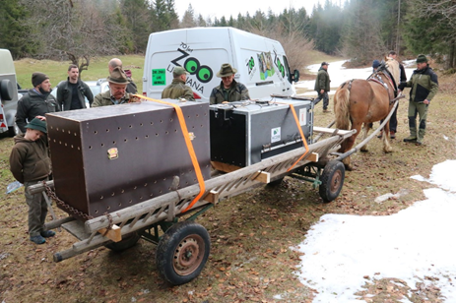

PHOTO 1: Arrival of lynx Zois and Aida to quarantine enclosure in Slovenia. A traditional horse-drawn carriage was used for the final transfer from the van to the enclosure. Photo: Maja Sever, LIFE Lynx

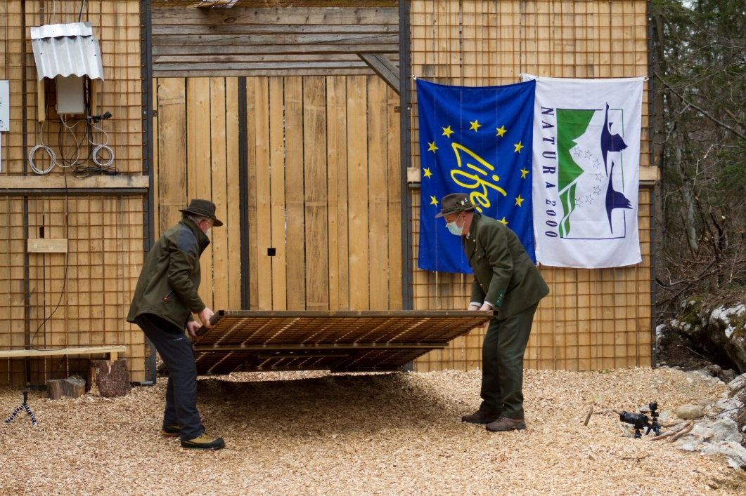
PHOTO 2: Local hunters opened the doors of the quarantine enclosure. Photo: Janez Tarman
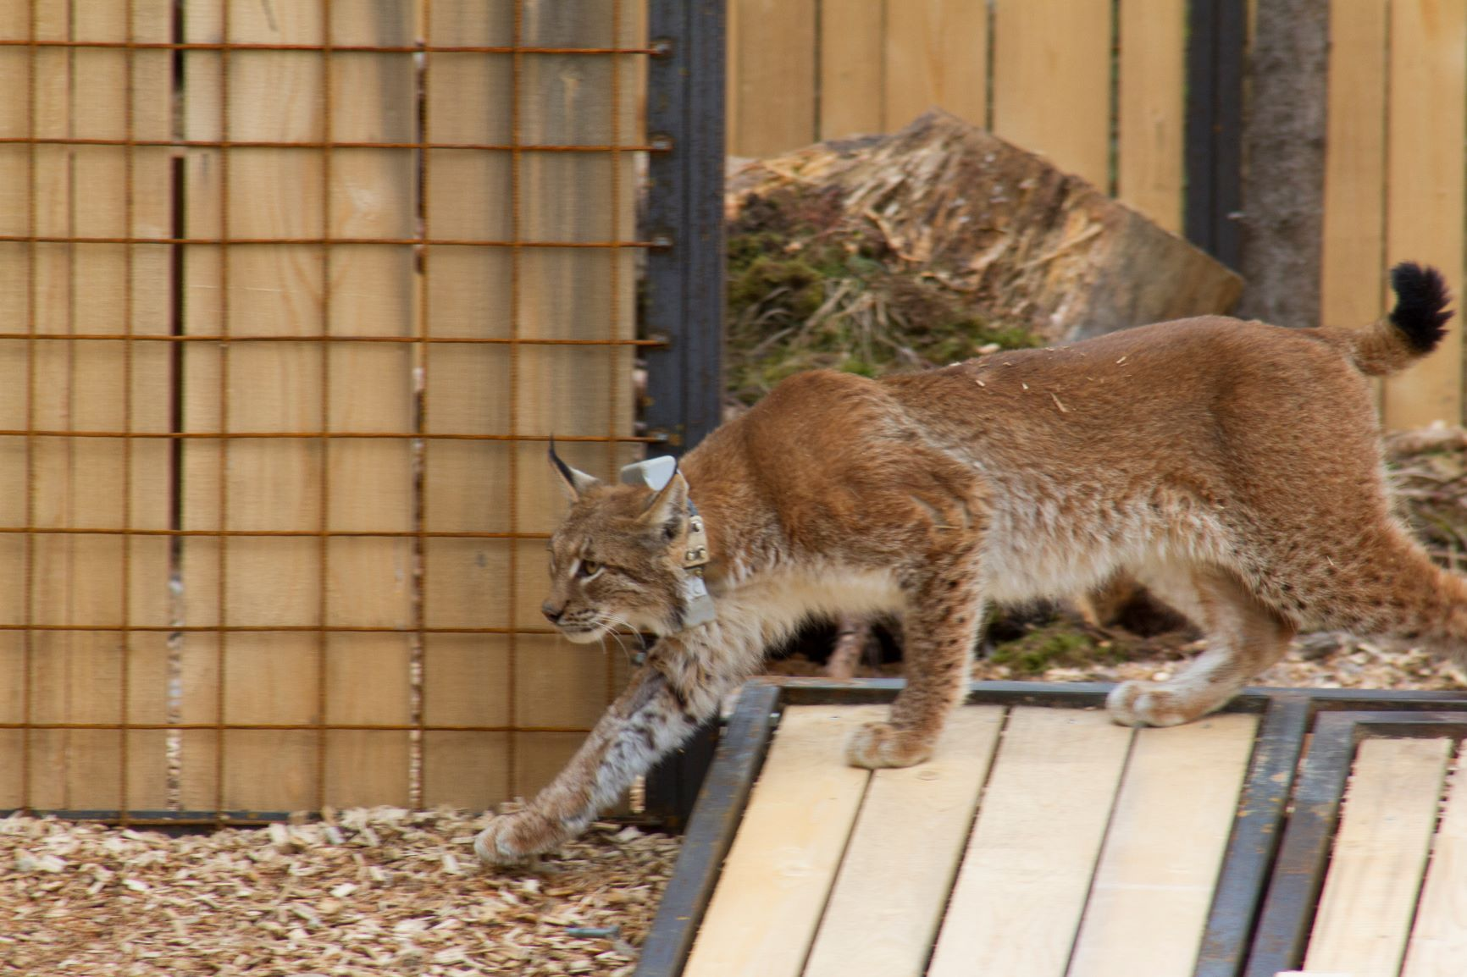
PHOTO 3: Release of lynx Aida. Photo: Janez Tarman

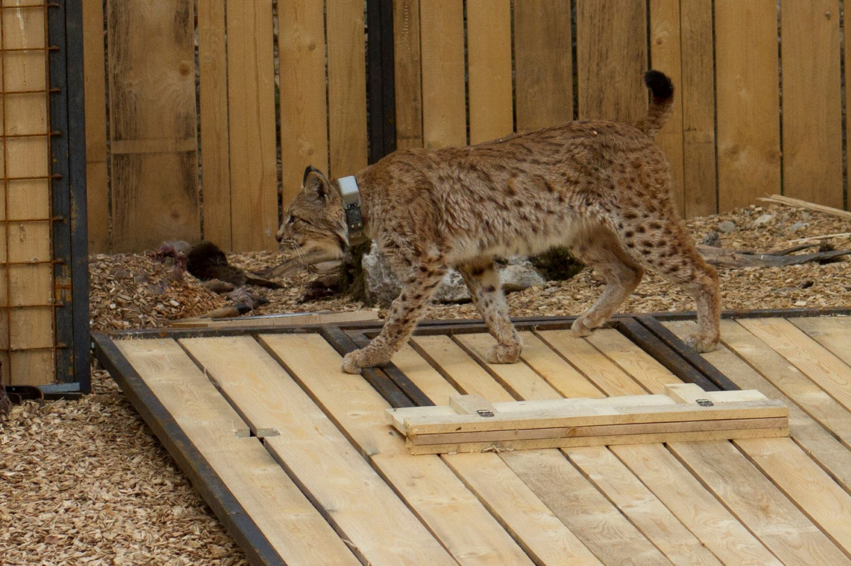
PHOTO 4: Zois’ first steps in Slovenian forests. Photo: Janez Tarman

